

PLEASE DOWNLOAD AND READ THIS QUICK START GUIDE
BEFORE ATTEMPTING INSTALLATION.

THANK YOU!

IF AFTER READING THIS MANUAL YOU HAVE FURTHER QUESTIONS CALL (407) 493.2355
Or
YOUR LOCAL REP:


Questions? Call: 407-493-2355
Orlando, FL. 32818

Residential Perfect Pressure Pump (RP3) Quick Start Guide.

- Plumb unit per local codes. PVC may not be appropriate in your area due to freezing. It is the installers responsibility to insure local codes are followed.
- The RP3 has a 1.25” inlet and 1.00” NPT outlet. Reducers can be used if needed (supplied by others).

Hooking up piping:
Suggested threaded connection procedure is 3 wraps of Teflon tape followed by pipe dope and then followed by three more wraps of Teflon tape. Had tighten followed by 1-2 turns with a pipe wrench. Allow to set for 60 seconds and tighten down another ½ turn or until aligned as needed.

Wiring:
These units are single phase 230 volt only. Suggested breaker is a 2 pole 15 or 20 amp. GFCI can be used if required by local code. Wire size is 14 or 12 gauge wire depending on wire length. Runs over 30 ft. is suggested 12 gauge wire.

Ready for water:
Before applying water affix and tighten cover on the VFD to prevent any water from entering the VFD. The VFD is waterproof but only if the cover is on and tightened down.

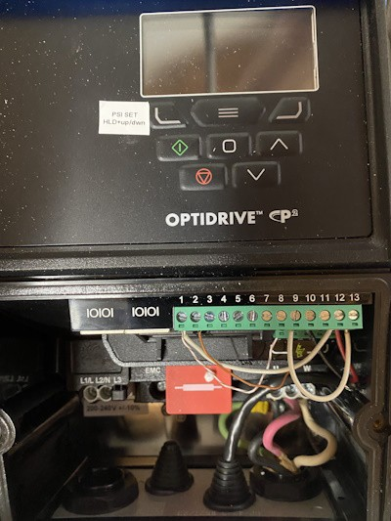
To set pressure push here while pushing up or down arrow keys until desired pressure displays.
Release buttons saves. Start button to run.

Stop button to stop. Also to reset a fault.
Display will alternate between actual and set point pressures, Amps, KW and Hz.

Enter button. To enter parameter settings push for 3 or more seconds. Saving a setting is also done by moment push.
Up button to advance in parameters or set pressure higher.

Down button to reduce in parameters or set pressure lower.

Connect 230v
1 phase to L1&L2. L3 No Connect.

Ground connection under chassis screw

Apply water and check for leaks. Repair any leaks prior to applying power.

If no leak then turn on power with the remote breaker (provided by others).
Once power is applied the display will alternate between actual pressure and set point pressure every 2 seconds. When you adjust the set point pressure by holding down the top left button while pushing the up or down arrow key the display will continuously show the set point pressure. Once the set point is at desired pressure, you can release the buttons and the setting will save.

If there is demand, the pump will start and attempt to maintain the pressure you set above. The pump will not start if there is no demand. If the pump can not reach the set point within 20 seconds the pump will shut down and display “Water Problem”. There are several reasons this may occur.
The most frequent is air in the line, especially in a new installation. You will see a hex nut at the 11 -12 O’clock position on the pump. With a towel handy, reset the drive by pushing the stop turn this CCW a ½ turn or until you get water leaking out. DO NOT take fully off. Do this while the pump is running. If air is present, you will see air bubbles with water. Allow the release of air & water until the air bubbles stop. Tighten back once no more bubbles are created. DO NOT over tighten.

If water problem still displays either there is not enough water going to the pump or you may be attempting to put out more pressure than the pump can deliver. After checking that the input has water, reduce the set point by 5 PSI until the issue stops. Note the Pump pressure set point needs to be at least 5 PSI above the input pressure.

VFD ADJUSTMENTS
- Minimum Pressure turn on P1-15
Also known as our electronic bladder tank algorithm.
Unlike competitors that require a bladder tank, the RP3 does not require one. The reason is this pump monitors BOTH the rate of pressure drop and actual pressure. If the pressure drops down to this minimum pressure the pump will come on and pump back to set point. TAW recommends you set this pressure to 5 PSI above the pressure coming into the home. You can tell this by turning off the pump with the stop button. Turn on a faucet and look at the actual pressure being displayed on the stopped pump. Set P1-15 to 5 PSI above this.

- To set ANY parameter the following procedure must be followed:
Push the enter button (top center button with a square) for 3 seconds, parameters will show. Scroll up the parameters by pushing the up arrow key until you reach P1-15.
Push the enter button again, this will display the present setting. (Default is 40 PSI). Push the up or down arrow key until this pressure is 5 PSI above the normal home pressure without the pump.

Finally save the setting by pushing the enter button again. 10 seconds later the display will return to the normal alternation of actual and set point pressure.

Turn On Sensitivity: P1-16.
The rate at which the pump determines true demand vs. a slow leak down is adjusted with this parameter. Most times this will not need to be changed but if the pump does not come on when a faucet is turned on you can make this more sensitive by reducing the number. Default is 3.

Setting procedure is the same as in P1-15 except you now go to P1-16.

Turn Off Sensitivity: P1-17.
The amount of water that goes through the pump before turning off. This is known as our no flow algorithm. To prevent the pump from overheating, if the water going through the pump reduces to close to zero the pump will turn off. This turn off point is adjusted using P1-17.
Adjustable from .5 – 3 GPM. The lower the number the more sensitive the turnoff becomes. Default of 17 is typically good for most applications but if you find the pump is not turning off and it is getting warm, adjust this down by 2 until the pump turns off with no flow. If the pump is NOT getting warm, there is water flowing through the pump either by a an RO system or some other demand in the house. It may take 20 seconds to turn off once no flow is reached.

Setting procedure is the same as in P1-15 except you now go to P1-17.

Shut off no flow current: P-18.
This is the current that must be below to allow the no flow to operate. This prevents the pump from turning off if the motor current is higher than this setting (60% motor amp rating default). This assumes the pump is pumping water if the current is at or higher than 60% FLA.
Setting procedure is the same as in P1-15 except you now go to P1-18.

Maximum Pressure Setting: P-20.
Default is 80 PSI. Consumer fixtures are rated to 80 PSI so do NOT attempt to raise this unless you have commercial fixtures or your house is on a hill from the pump. This setting is in percentage of the transducer rating. So if there is a 100 PSI transducer this setting will be at 80 presenting 80% of 100 PSI or 80 PSI. If the transducer is a 200 PSI it will be set to 40, 40% of 200 or 80 PSI.

Setting procedure is the same as in P1-15 except you now go to P1-20.

These are the only critical settings, the pump should now turn on when there is demand and shut off after 20 seconds of no demand.
If you have any issue, concerns or questions, feel free to call TAW at (407) 493.2355 M-S 8 am- 8pm EST.

Enjoy your higher home pressure.

